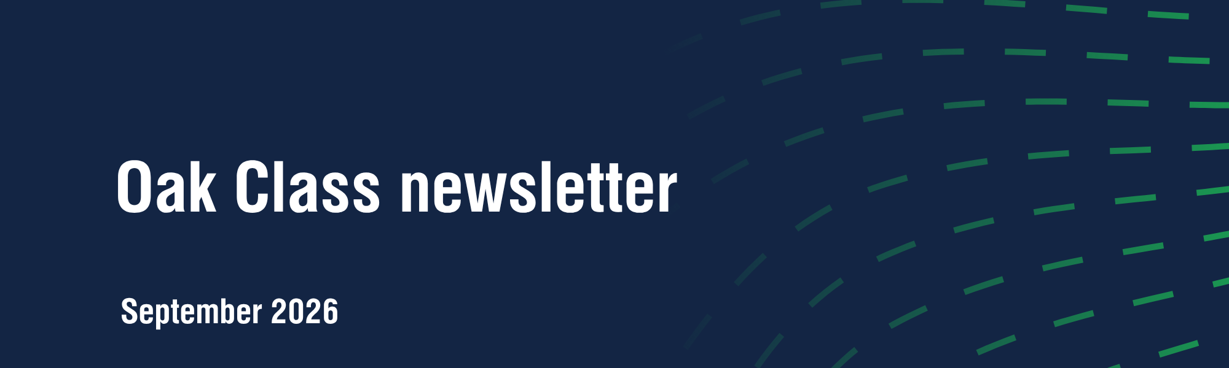
From Flint to Iron.
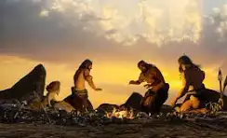

This term we will be finding out about life in Stone Age Britain. We will be reading books in English that complement this topic, such as The First Drawing, The Tin Forest and The Fossil Hunter. We will also read a non-fiction book about Ancient Civilisations. Even children who are fluent readers need to read regularly at home as well as at school, please aim for your child to read at home five times a week. If they do this, they will move up on the Bawdsey bookworm and receive awards for their reading.
In Maths, the first unit is about place value. To make progress in Maths, it is crucial that children know their multiplication tables; in Y3 /4, we really push this. In the summer of Year Four the children take the national multiplication tables check. By this time they are expected to understand and rapidly recall their tables up to 12 x 12. They start with the 2s and work their way through every multiplication table. These will be tested each week, certificates are awarded in assembly and the children are very motivated to learn all their tables. We use times tables rockstars for this, please ask if you have any problems logging in at home.
Our Science topic is sound and vibrations and we will conduct various experiments on this topic, it will be noisy!
Other information.
Year 2 will join Y3/4 for the afternoons every day apart from Thursday. Science and French will be taught on Thursday afternoons, while Art, Music, PE, DT, ICT, PSHE and History /Geography will be taught to Years 2, 3 and 4 together. The learning objectives will be taught for the different year groups, there will be a teaching assistant to ensure everyone can be given the appropriate level of challenge.
Mrs. Lincoln will teach the class for the whole day on Tuesdays, and on Wednesday afternoons as I have additional leadership time this term.

