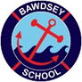
Bawdsey CEVC Primary School
School Lane, Bawdsey, Woodbridge, Suffolk, IP12 3AR
Headteacher: Mrs Katie Butler
T: 01394 411365
Email: admin@bawdsey.suffolk.sch.uk

Re: RSE and PSHE curriculum consultation

Dear Parents and Carers,

You may well have seen that certain elements of Personal Social Health Education (PSHE) are about to become compulsory. These are the areas of Relationship Education and Health Education.

As a school we must have implemented these curriculum changes by September 2020 and the Department for Education is giving strong advice to start teaching them from September 2020. We know that certain topics within these curriculum areas may potentially cause concern for parents. We also know that elements of this curriculum are already being misrepresented in the media and so we wanted to give you, our parent body, the correct information about the changes that are coming and the chance to view, not only the new legislation, but also the award winning resource we have chosen to support your children’s learning within these key areas.

The new curriculum areas are currently in draft format but as there has been such widespread support from government, parents, schools and the Department for Education we expect there to be little change between the draft and the final guidance. If you would like to know more about what your child will be learning you can find it by following this link:
https://assets.publishing.service.gov.uk/government/uploads/system/uploads/attachment_data/file/781150/Draft_guidance_Relationships_Education__Relationships_and_Sex_Education__RSE__and_Health_Education2.pdf
Teaching Expectations for Relationship Education from page 19
Teaching Expectations for Health Education from page 31

Please see the parents’ consultation PowerPoint for more information regarding the changes to the curriculum, how we are teaching RSHE in school and an insight into our One Decision scheme of work. We will be sending out a questionnaire shortly for you to show us your feelings about the documents and scheme we are using.

If you would like to know more, or ask questions, please contact Miss Mee via the admin email address.

Kind regards,

Emily Mee
PSHE and RSE lead

Understanding Relationships and Health Education in your child’s primary school: a guide for parents
We want all children to grow up healthy, happy, safe, and able to manage the challenges and opportunities of modern Britain. That is why, from September 2020, all primary age children will be taught Relationships and Health Education.

These subjects are designed to equip your child with knowledge to make informed decisions about their wellbeing, health and relationships as well as preparing them for a successful adult life. The world for all young people looks very different from the way it did 20 years ago when this curriculum was last updated – these changes bring the content into the 21st century, so that it is relevant for your child.

Your child’s school will have flexibility to deliver the content in a way that is age and developmentally appropriate and sensitive to the needs and religious background of its pupils.

Relationships Education
By the end of primary school, pupils will have been taught content on:

- families and people who care for me
- caring friendships
- respectful relationships
- online relationships
- being safe

You can find further detail by searching ‘relationships and health education’ on GOV.UK.
Relationships Education will put in place the building blocks needed for positive and safe relationships, including with family, friends and online.

Your child will be taught what a relationship is, what friendship is, what family means and who can support them. In an age-appropriate way, your child’s school will cover how to treat each other with kindness, consideration and respect.

Health Education
By the end of primary school, pupils will have been taught content on:

- mental wellbeing
- internet safety and harms
- physical health and fitness
- healthy eating
- facts and risks associated with drugs, alcohol and tobacco
- health and prevention
- basic first aid
- changing adolescent body

You can find further detail by searching ‘relationships and health education’ on GOV.UK.
Health Education aims to give your child the information they need to make good decisions about their own health and wellbeing, to recognise issues in themselves and others, and to seek support as early as possible when issues arise.
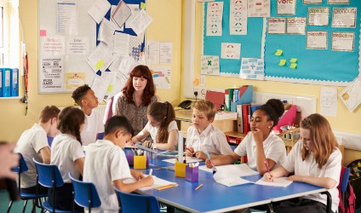

Your rights as a parent
The important lessons you teach your child about healthy relationships, looking after themselves and staying safe, are respected and valued under this new curriculum. Teaching at school will complement and reinforce the lessons you teach your child as they grow up.

Your child’s school is required to consult with you when developing and renewing their policies on Relationships Education. These policies must be published online and be available to anybody free of charge.

You can express your opinion, and this will help your child’s school decide how and when to cover the content of the statutory guidance. It may also help them decide whether to teach additional non-statutory content. Schools are required to ensure their teaching reflects the age and religious background of their pupils.

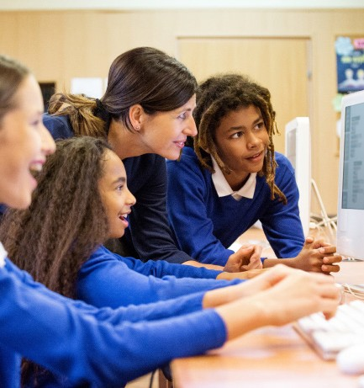
Some schools will start to teach these subjects from September 2019 – if you’d like to know more, please speak to your child’s school about what they plan to teach.
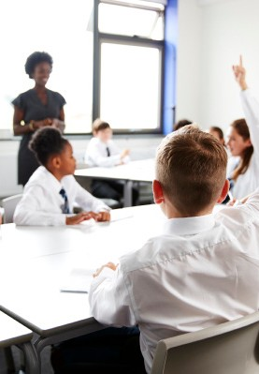

Right to withdraw your child
You cannot withdraw your child from Relationships Education because it is important that all children receive this content, covering topics such as friendships and how to stay safe.

Your child’s primary school can choose to teach Sex Education. If you’d like to know more about this, we recommend speaking to the school to understand what will be taught and when. If you do not want your child to take part in some or all of the lessons on Sex Education, you can ask that they are withdrawn. At primary level, the head teacher must grant this request.

The science curriculum in all maintained schools also includes content on human development, including reproduction, which there is no right to withdraw from.




If you want to know more about what will be taught as part of the new subjects, the best thing to do is speak to your child’s school.

