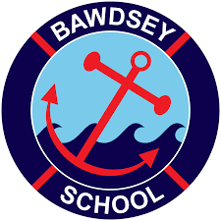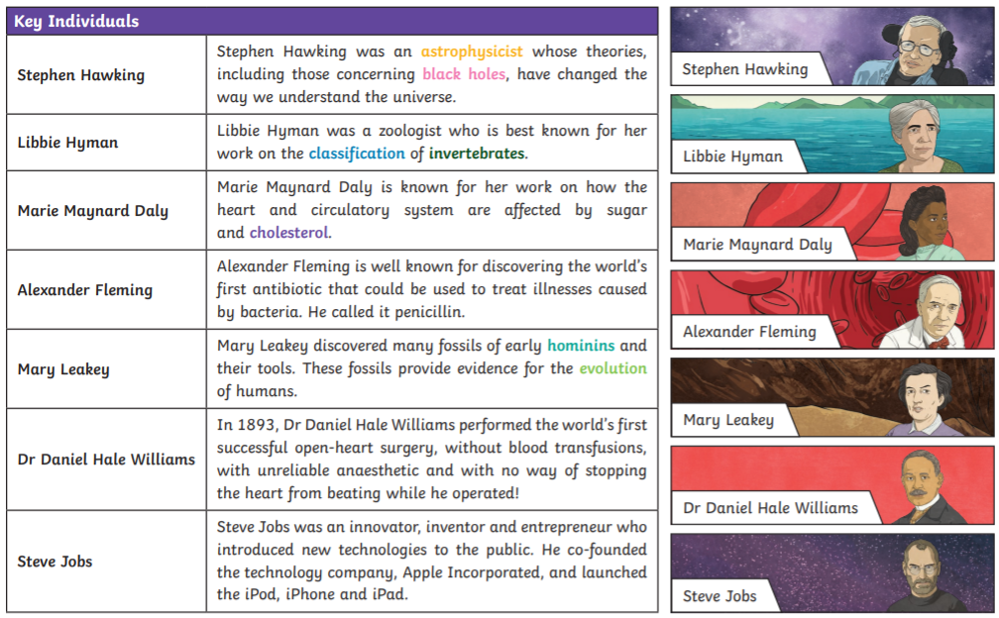

**Bawdsey Primary Year 6- Scientists and Inventors  
*Caring, resilience, explore, courage, equal. (ALL 5)***

