Bawdsey Primary Explore Courage Equality

Year 1 Kings and Queens Resilience Caring

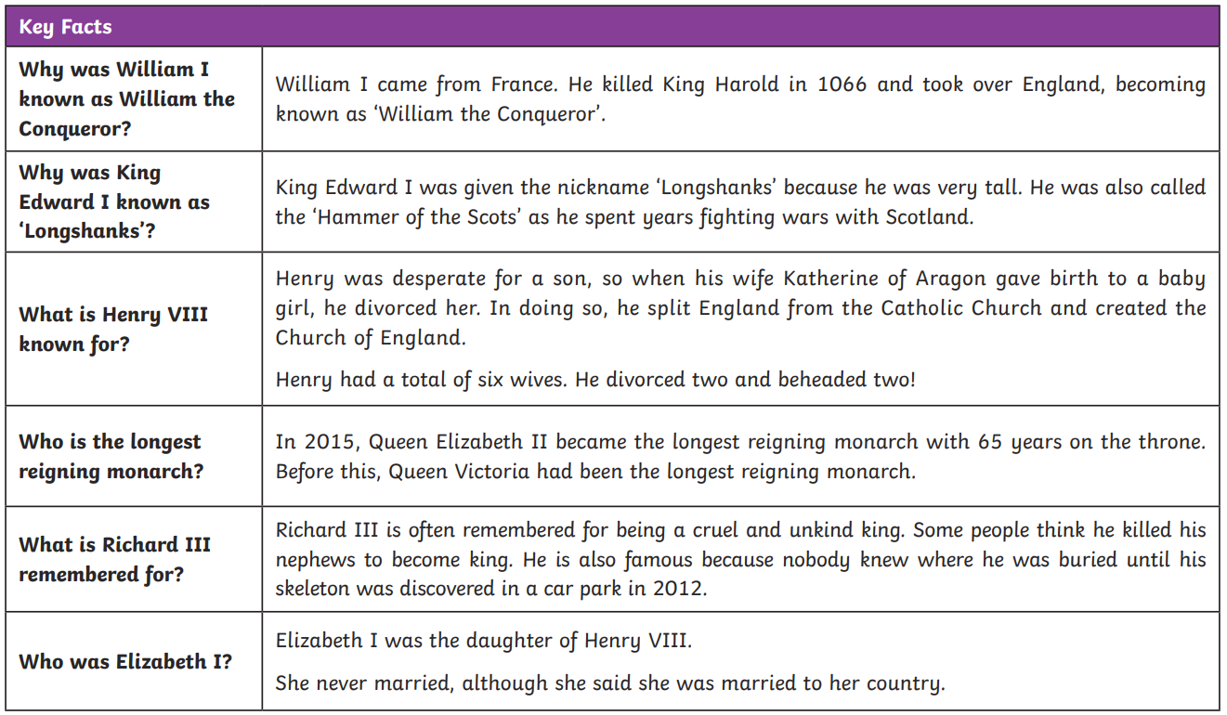

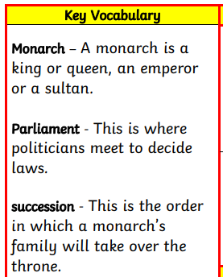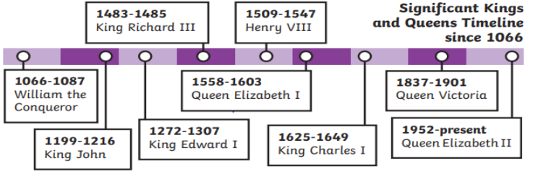

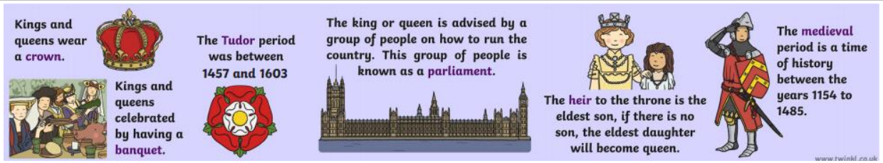

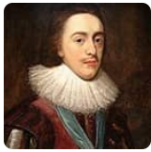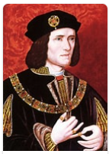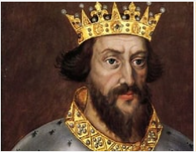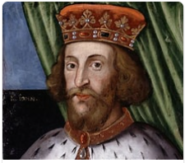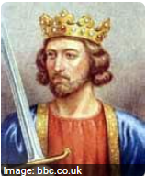

William the Conqueror King John Edward I Richard III Henry VIII Elizabeth I Charles I

Some kings and queens have Roman Numerals after their names, like Elizabeth I. This means there has been another king or queen with the same name and helps us to know which one we are talking about.