Bawdsey Primary Explore Courage Equality
Year 1 Changes beyond living memory Resilience Caring

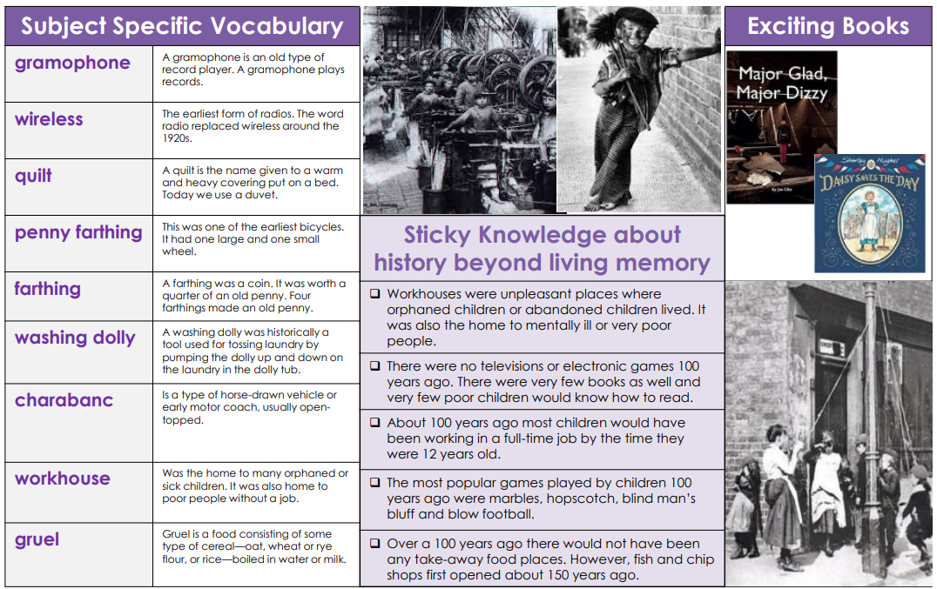

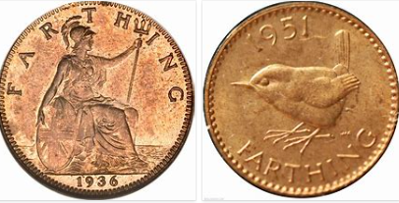
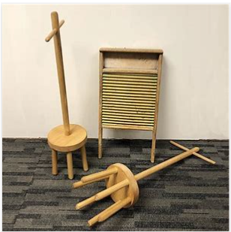
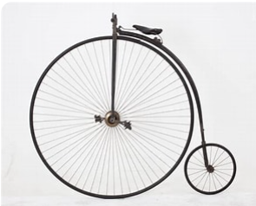
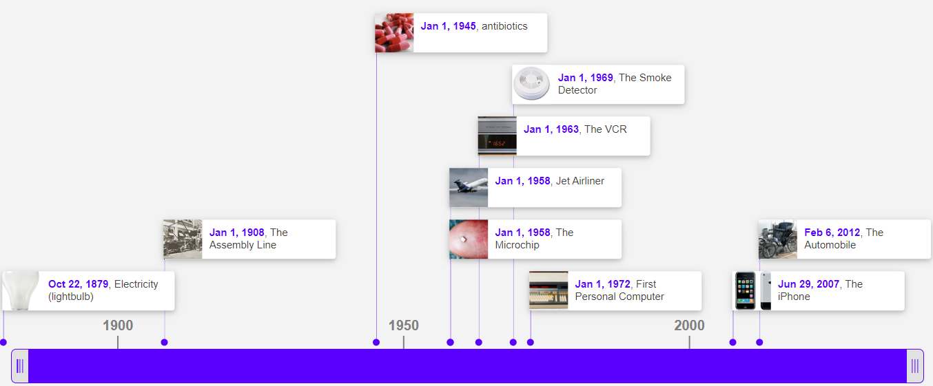
Penny Farthing Farthing Washing dolly→

TECHNOLOGY TIME LINE

