Bawdsey Primary Explore Courage Equality
Year 1 Changes in Living Memory Resilience Caring

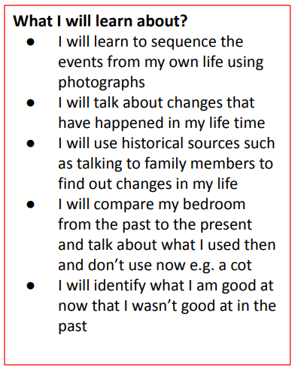
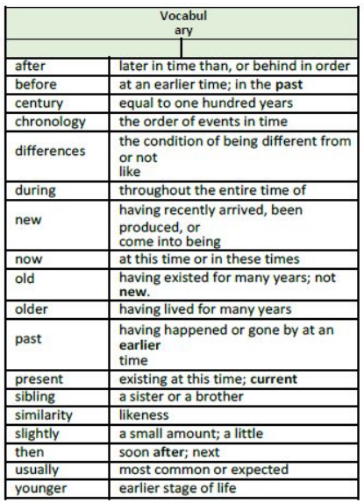
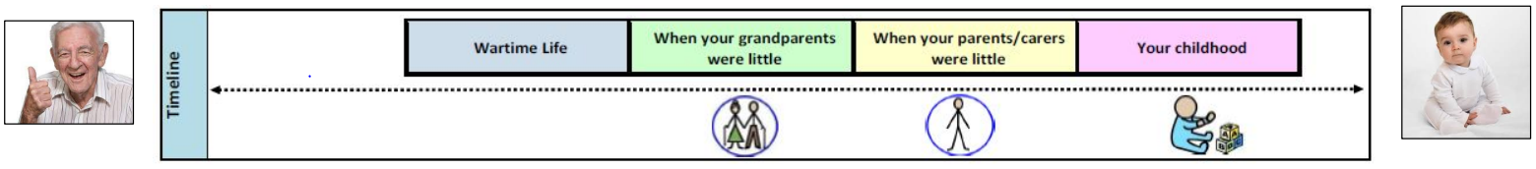
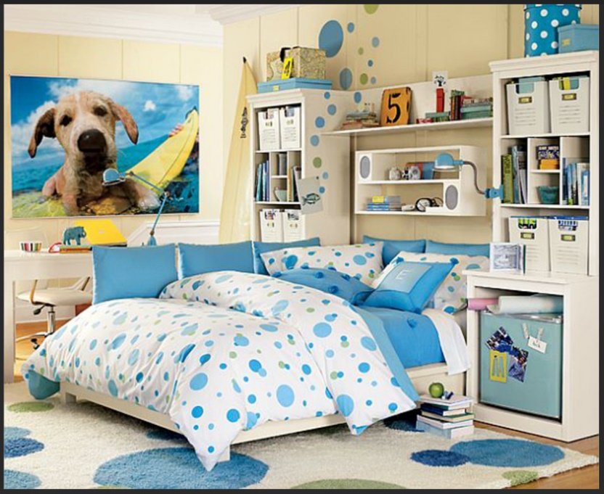
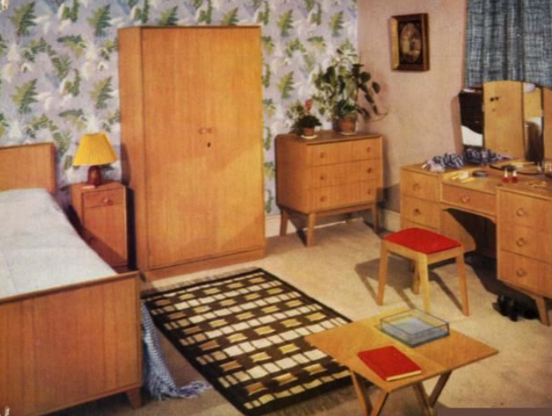
1960s bedroom Present day bedroom
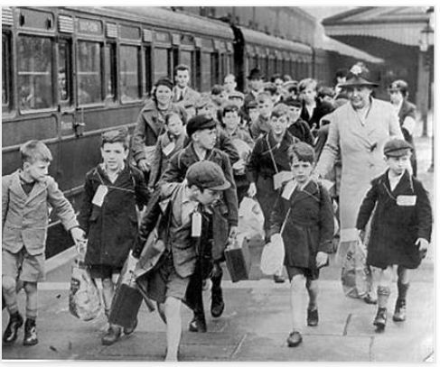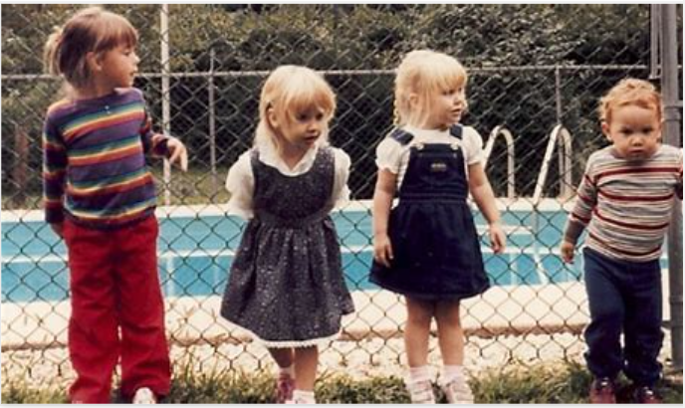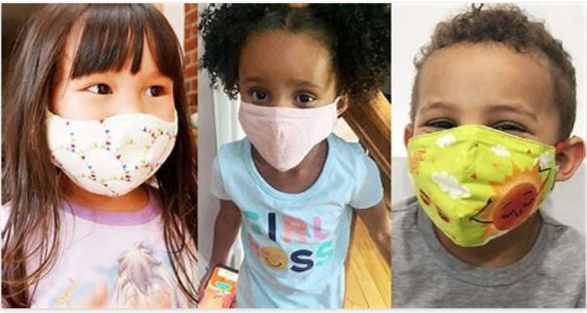
War time children (Grandparents) 1980s (Parents) 2020 Present day

