Bawdsey CEVCP School Newsletter
We have got God’s world in our hands
Contact Email: | admin@bawdsey.suffolk.sch.uk | Phone number: | 01394 411365
10th October 2022
Awards of the week
Nursery: Lainey for having a great first week in Nursery and settling in so well.
Starfish class: George M for superb Phonics and Handwriting.
Seahorse class: Ashtyn for his excellent writing all about Leaf.
Turtle class: George S and Arthur for excellent writing.

Bawdsey football team: Cheska, Kit, Hector, James, Freddie, Eli B, Kayden and Adi. Excellent game guys well done!
A big well done to Eli B for winning the FAIR PLAY award at the football match.
Parent/ Carer meetings about settling in…
Parents/ Carers are invited to our usual first meeting about how children have been settling in on Tuesday November 1st. This is primarily for any year groups new to their class: Reception, year 2, year 4 and other children in Dolphin class. However, anyone who have children in other year groups who would like a slot of time with the class teacher are welcome to sign up too. Signing up to a slot is through parent pay. If you cannot attend on the 1st and would like a meeting, please ask your child’s class teacher to arrange a different slot that is mutually convenient. If you wish to meet prior to this then please let us know.

If you are concerned about anything or if you have a query about your child’s education, please do not wait for this meeting and talk to your child’s teacher as soon as possible. We will always try to help, support, or resolve issues when we are made aware of them. Thank you.
The grand totals…
The Macmillan coffee and open afternoon raised £137.25, thank you!
The sponsored walk raised a massive £1,128.25 for the BSA (Bawdsey School Association- equivalent of PTA) for forest school resources, playtime resources and library books.
Football competition
The children played well and had a great time. They were a credit to the school.
Spare shoes, coats and wellies
Please can the children have a spare set of shoes (Old trainers, wellies or something) to go onto the field at playtimes and for the Bawdsey Bolt each day please.
Please can the children in Starfish class on a Friday afternoon have coats and wellies in school please for beach school sessions.
Please can the children have a jumper or cardigan, and a coat sent every day. Thank you all.
Welcome
We would like to welcome Miss Scarce to the school as a new Teaching Assistant, I am sure you will welcome her.
Homework celebrating the European Day of Languages
We are looking forward to seeing the fun the children are having with the European Day of Languages challenge. We have chosen French because that's the language we learn in school, but we are happy to see any language being explored.
Harvest festival
We are holding our Harvest festival at 9.30am on Tuesday 18th October (this has just been confirmed by the church). The classes will each be helping during the service. Please could you donate an item of non-perishable food which we will give to the Salvation army food bank for families who need it. If you would like to join us in the church, please can you ask at the office to be added to the list for the extra seats so we can ensure everyone is seated. Thank you.
Choking risk at lunchtimes
Please can any children who are having grapes, cherry tomatoes, olives or other fruit or vegetables of a similar shape or size sent in packed lunches have them pre-cut at home first. There is a real risk of choking without having them cut up. Please see the picture prompt below.
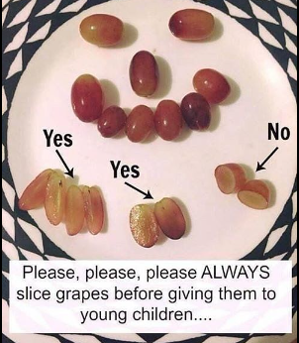
Below is guidance from the Food and Standards agency which is especially important for children under 5 years old.
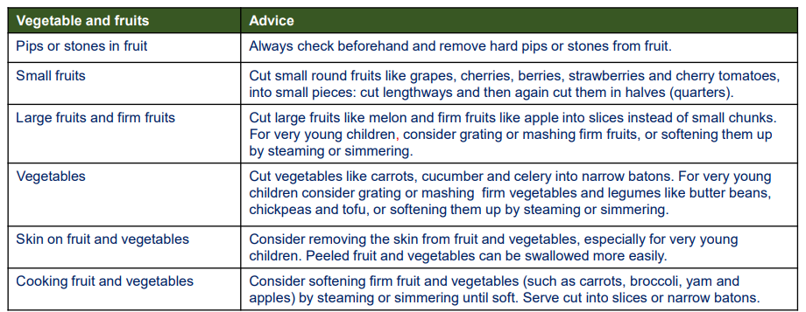
Monday | Tuesday
 | Premier sports club Yrs 2-6 3.15-4.15
Wednesday | Thursday
Friday
Chess club Yrs 2-6
Future Dates
Changed or new dates will be in Red - we will try not to change the dates below but when planning so far in advance sometimes we may have to adjust them as we go through the term.

14-10-22 (Fri) Sharing assembly parents/ carers welcome. Seahorse class 10.30 am.
18-10-22 (Tues) 9.30am. Harvest festival at Bawdsey church. If you would like to attend, please let us know as there are limited spaces for Parents/ Carers and we will be making a list for the additional seats. Please can the children also bring in an item or non-perishable food on the day. Thank you.
18-10-22 (Tues) 3:20pm. Informal meeting with Mr Wyllie, Chair of Governors, Mrs Butler and Miss Mee about the changes with Mrs Butler returning after half term. (Childcare of school aged pupils will be provided in after school club- free for the duration of this meeting.)
01-11-22 (Tues) Parent/ Carer meetings about settling in. If the date does not work or you would like a meeting before this date, please contact the office.
21-10-22 (Fri) PD Day. School not open to pupils- staff training day.
24-10-22 – 30-10-22: October half term break. School not open to pupils.
11-11-22 (Fri) Remembrance Day. Sharing assembly parents/ carers welcome. Starfish class 10.45 am.
14-11-22 (All week) Anti bullying week.
15-11-22 (Tues) Flu vaccinations in school- more information to follow.
16-11-22 (Wed) Bowling competition with selected pupils.
19-11-22 (Fri) Tag rugby competition with selected pupils.
1-12-22 (Thurs) Christmas craft afternoon in school.
2-12-22 (Fri) Flu vaccines in school- more information to follow.
6-12-22 (Tues) Nativity performance for families by Starfish class (including Nursery).
7-12-22 (Wed) Christmas jumper day, Christmas dinner day and whole school beach walk.
16-12-22 (Fri) Christmas Carols around the tree (pm time to be confirmed). Last day of term.
17-12-22 – 3-1-23 Christmas holidays.
4-1-23 (Wed) Children in school to start the Spring term.

